Agile Group Project

By

Nishant Singh

Sukhdeep

Nirmal

Anmoldeep Singh

Contents

Introduction 3

Project Members 4

Time Schedule 4

Agile Methodology 5

Pages and Mock-ups 5

Design Page 5

Article Page 6

Testing 7

Conclusion and future Work 7

# Introduction

The main aim of this project is the design of an agile / scrum mobile application. We have created an application for finding the Rugby News using

RestSharp Library where xml is used as input. RestSharp is an all-round HTTP client library open source that deals with DotNet technologies of all kinds. This enables flexible applications to be developed by enabling integration to public APIs and fast access to data without the hassle of dealing with raw HTTP requests. RestSharp blends many benefits with a clean, simple interface, making it one of today's hottest REST devices.

REST (or RESTful) Services are an increasingly common paradigm for creating web services because of their simplicity and inherent platform agnostic approach. Many of the major service providers use REST, such as Twitter, Flickr, Facebook, etc. REST allows for stateless, cacheable, and simple to consume client-server architecture over HTTP.

In order to access the news from herald related to Rugby we used REST API where xml feed is used as input. In order to access the input, we need to deserialize the xml. Deserialization is used to convert the byte of data, such as XML or binary data, to object type. Serialization is the process of converting an object into a form that can be readily transported.

For example, you can serialize an object and transport it over the Internet using HTTP between a client and a server. On the other end, deserialization reconstructs the object from the stream. XML serialization results in strongly typed classes with public properties and fields that are converted to a serial format (in this case, XML) for storage or transport. To deserialize the XML we need to create a class that maps the XML document we want to read.

In this Rugby News application, We access the RSS feed from the NZ herald website: <http://www.nzherald.co.nz/rss/> and use the <http://rss.nzherald.co.nz/rss/xml/nzhrsscid_000000080.xml> feed for rugby.

In this app there are two main screens one is design screen which highlights the various news related with rugby, when user click or select a news the article page displays the whole news article.

# Project Members

In order to increase the effectiveness of the application, five team members are participating in a different role that is given in the below table:

|  |  |
| --- | --- |
| Name of team Member | Role |
| Nishant Singh | Team Leader and Back End Developer (API) |
| Sukhdeep | Front End Developer |
| Nirmal | Web Designer |
| Anmoldeep Singh | Application Tester |

All members make their own attempts to successfully complete the project and to meet the needs of the client.

# Time Schedule

|  |  |  |  |  |  |  |  |  |  |  |  |  |  |  |  |
| --- | --- | --- | --- | --- | --- | --- | --- | --- | --- | --- | --- | --- | --- | --- | --- |
| **Stages** | **Activities** | **Duration**  **Week1-2** | | | | **Duration**  **Week-2-3** | | | | | **Duration**  **Week-3-4** | | | | |
| Project Planning | Research |  |  |  |  |  |  |  |  |  |  |  |  |  |  |
| Start of Meeting |  |  |  |  |  |  |  |  |  |  |  |  |  |  |
| Project Proposal and documentation |  |  |  |  |  |  |  |  |  |  |  |  |  |  |
| Project Execution | Application Design |  |  |  |  |  |  |  |  |  |  |  |  |  |  |
| UI Design |  |  |  |  |  |  |  |  |  |  |  |  |  |  |
| Coding |  |  |  |  |  |  |  |  |  |  |  |  |  |  |
| Testing |  |  |  |  |  |  |  |  |  |  |  |  |  |  |
| Final | Documentation and Report |  |  |  |  |  |  |  |  |  |  |  |  |  |  |

# Agile Methodology

The Agile approach is used as an alternative to traditional methods in this project. This strategic approach is highly effective and pragmatic and tackles the changing needs of the technology.

In this project, our group used the agile / scrum approach. At the beginning, the team members define and fulfil all criteria. The team then decided to implement the special feature of the Rugby News application in order to meet the needs of users.

Many improvements have been made to make this programme more user-friendly. After all enhancements have been made, the app is available for the use of users.

# Pages and Mock-ups

## Design Page

This is the main page of the application. On this page there are various news related to rugby. User can select any news of their choice and click on that news in order to read the news in more detail.

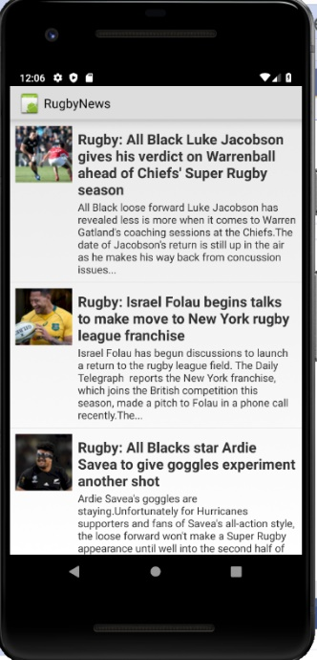

# Article Page

With the help of this page user can read the whole news in detail. When your click on the news in the home/design page, it will lead to the article page.

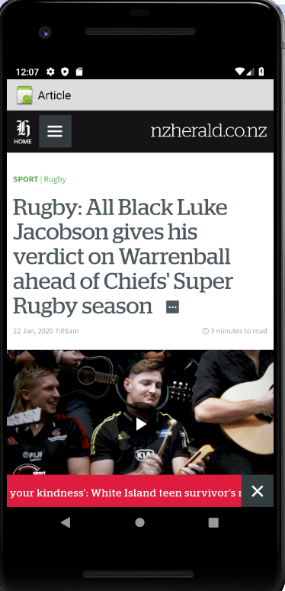

# Testing

Due to the limited time available, we just conducted the usability testing of the project which can be found at [Usability Testing.xls](Usability%20Testing.xls)

# Conclusion and future Work

In short, this project is built on an agile scrum approach in which the IT group has developed the so-called Rugby News Android application. Due to the limited time, we just build a small application. However, this application can be further improved, and more features can be added such as: different categories of news can be added, and all of that news can be available via one application.